SELECT username,nombre,email, GROUP_CONCAT(roles.name) FROM usuario

JOIN role_user ON role_user.user_id = usuario.id JOIN roles ON roles.id=role_user.role_id

WHERE email LIKE "%fintra.co"

GROUP BY role_user.user_id

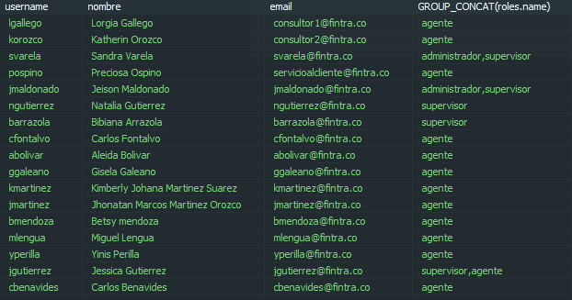

**SELECT* FROM caso**

**WHERE created_at BETWEEN "2019-02-08 14:00:00" AND "2019-02-08 14:30:00"**

**AND asignado = 5**

**Casos creados entre las 2:00 p.m. y las 2:30 p.m. y asignados al usuario 5**

**SELECT** **COUNT**(created_at) **FROM** registro_canal

**WHERE** created_at **LIKE** "2019-03-27%" **AND** contenido = "Llamada Entrante"

**LIMIT** 1500

Conteo de llamadas ingresadas el día 27/03/2019

**SELECT** * **FROM** registro_canal

**WHERE** created_at **LIKE** "2019-03-27%" **AND** contenido = "Llamada Entrante"

**LIMIT** 1500

Muestra los llamadas ingresadas el día 27/03/2019

SELECT campo1, count(*)

FROM tabla1

GROUP BY campo1

HAVING count(*) > 1

Conteo y busqueda de duplicados

SELECT * FROM asterisk.cdr

WHERE LENGTH(src)=4 AND LENGTH(dst)>8

AND clid NOT LIKE '%<5380>'

AND disposition LIKE 'answer%'

AND calldate BETWEEN '2019-04-01 00:00:00' AND '2019-04-30 23:59:59'

AND lastapp LIKE 'Dial'

ORDER BY calldate DESC

SELECT cdr.clid as origen,

cdr.dst as destino,

CEIL(billsec/60) as minutos

FROM asterisk.cdr

WHERE cdr.calldate > '2019-04-01 00:00:00'

AND cdr.calldate < '2019-04-30 23:59:59'

AND cdr.src LIKE '53%' AND LENGTH(cdr.src) = 4

AND cdr.billsec > 0 AND cdr.dst != '2600'

AND LENGTH(dst)> 8 AND src != '5380'

AND disposition LIKE 'answer%'

SELECT tmp.usuario_id,

u.nombre,

u.email,

u.deleted_at,

u.habilitado,

GROUP_CONCAT(DISTINCT r.name),

GROUP_CONCAT(DISTINCT c.nombre),

GROUP_CONCAT(DISTINCT tc.nombre)

FROM

(

SELECT aea.usuario_id, cc.campana_id, cc.canal_id

FROM agente_estado_agente aea

INNER JOIN agente_campana_canal acc ON acc.usuario_id = aea.usuario_id

LEFT JOIN campana_canal cc ON cc.id = acc.campana_canal_id

WHERE aea.created_at BETWEEN '2019-04-01 00:00:00' AND '2019-04-30 23:59:59'

GROUP BY aea.usuario_id, cc.campana_id, cc.canal_id

UNION

SELECT cs.usuario_id, cc.campana_id, cc.canal_id

FROM campana_supervisor cs

INNER JOIN campana_canal cc ON cc.campana_id = cs.campana_id

WHERE ((cs.created_at <= '2019-04-30 23:59:59') AND

(cs.deleted_at IS NULL OR cs.deleted_at BETWEEN '2019-04-01 00:00:00' AND '2019-04-30 23:59:59'))

UNION

SELECT u2.id, null, null

FROM usuario u2

LEFT JOIN role_user ru2 on u2.id = ru2.user_id

WHERE ru2.user_id = u2.id AND ru2.role_id = 1

) tmp

LEFT JOIN usuario u ON u.id = tmp.usuario_id

LEFT JOIN role_user ru ON ru.user_id = u.id

LEFT JOIN roles r ON r.id = ru.role_id

LEFT JOIN campana c ON c.id = tmp.campana_id

LEFT JOIN canal cn ON cn.id = tmp.canal_id

LEFT JOIN tipo_canal tc on cn.tipo_canal_id = tc.id

GROUP BY tmp.usuario_id

SELECT c.id,c.cliente_id,primer_nombre,primer_apellido,descripcion,c.created_at,COUNT(*) FROM caso c

JOIN cliente cl ON c.cliente_id = cl.id

WHERE c.created_at >'2019-06-01%'

AND descripcion NOT LIKE ''

AND campana_id = 10

GROUP BY cl.id, descripcion

HAVING COUNT(*)>1

ORDER BY created_at DESC